Sunrise OTS_WebService_GetMaterialDetail

TIBCO Detailed Design

Author: Deloitte
Creation Date: Aug 10, 2005
Last Updated: Oct 10, 2005

Revision History
Date | Description | Author/Review | Version
08/30/2005 | Initial version created | Hitesh Salla | 1.0
10/10/2005 | Updated with the changes as per CR | Arun Bhandari | 2.0

Related Documents
Date | Version | Document Name | Description
 |  | VI_SL_SAP_Material_Services-v01.doc | Functional Document
 |  | MaterialInterface.doc | Interface Document
 |  | HMCO_Sunrise_OTS_GetMaterialDetail_TIBCO_Mapping.xls | Mapping Spreadsheet

Table of Contents

1.0 Introduction 4
1.1 Purpose 4
1.2 Audience 4
2.0 OTS_WebService Project Architecture 5
3.0 GetMaterialDetail 7
3.1 Logical Design 8
3.2 Physical Architecture (Topology) 9
3.3 Event Flow 10
3.4 Block Diagram 11
3.5 Activity Diagram 12
3.6 Configuration Details 14
3.7 Use Cases 15
3.8 Key Performance Indicators / Metrics 16
3.9 Logging and Error Handling 17
3.10 Mapping Detail 18
3.11 Cross Reference Details 19
3.12 Business Works Component Inventory 20
3.13 Assumptions 21
3.14 Issues 22
3.15 Sign-off 23

- Introduction

1.1 Purpose

The scope of this document is to provide the technical design for the following web services in the Enterprise_Webservices TIBCO project:

GetMaterialDetail

This project contains all the web services that are a part of the Sunrise project. These services provide a web interface to access and/or update SAP. This is required for the existing SFA applications and eCommerce solution which need to update SAP. The project contains Sunrise Business Services (SBS), mostly by SAP systems. Each interface in FRICE is represented as a SBS.

1.2 Audience
This document contains information that can benefit TIBCO developers and architects. The reader should have an understanding of EAI (Enterprise Application Integration) technology and the tools used by the HMCo Integration Center for business integration (e.g. TIBCO)

- OTS_WebService Project Architecture

The figure below reflects the TIBCO Business Works project architecture to create the web services for the Sunrise project. Legacy systems (through TIBCO) need to interact with SAP to support various business processes like Invoicing, Order Status etc. within the OTS space. The TIBCO project has defined web-services to support these requirements. These web-services make a remote function call to the SAP exposed services. Most of these web services are RPC based (synchronous).

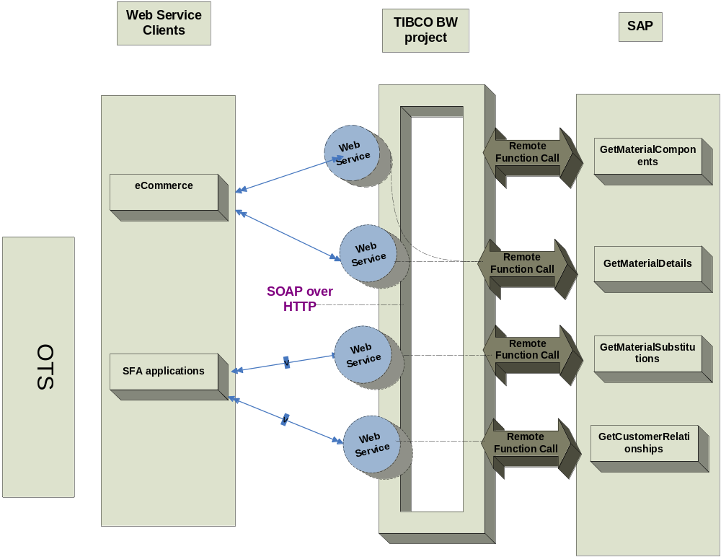
Figure 1.0 Project Architecture Diagram

TIBCO web services would define the WSDL (Web Service Definition Language) for each of these services. The legacy systems, i.e. eCommerce and SFA systems would use these to develop the client for these web-services. The legacy systems would then use these web clients to interface with the TIBCO exposed web-services.
The diagram below illustrates this.

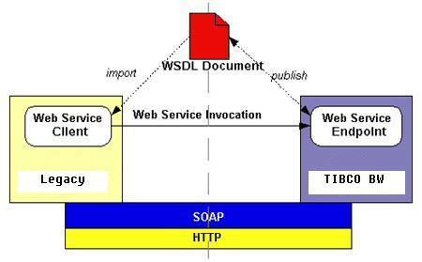

Each interface is represented as a Sunrise Business Service (SBS) within the OTS space for SAP - Legacy interactions. Below is a list of services/interfaces that are provided by SAP and exposed in this project as web services.

FRICE. ID | Interface Description | Process Name
429 | Retrieves various attributes about a given material | GetMaterialDetail

- GetMaterialDetail
As per the new environment with SAP, TIBCO would wrap the SAP services for submitting a request (Material ID) to get a material details into a web service. The legacy System would make a HTTP request sending in the request as per SOAP specifications. The webservice would extract the information and then would invoke the remote SAP function. The SAP function would do the desired processing, and would return the material component information if it were successful or error information if it failed. This status along with the returned information will be sent by TIBCO to the SOAP client via a HTTP response.
The clients would send a request - ‘Material ID’, that could be either a list of valid material numbers or a list of valid ISBN numbers to TIBCO. TIBCO would require converting the request from the SOAP message, to the required SAP format as per the mapping rules in the mapping spreadsheet. On receiving the response from SAP, TIBCO would convert it back to SOAP reply or SOAP fault format, depending on whether success or exception was returned by SAP.

Logical Design
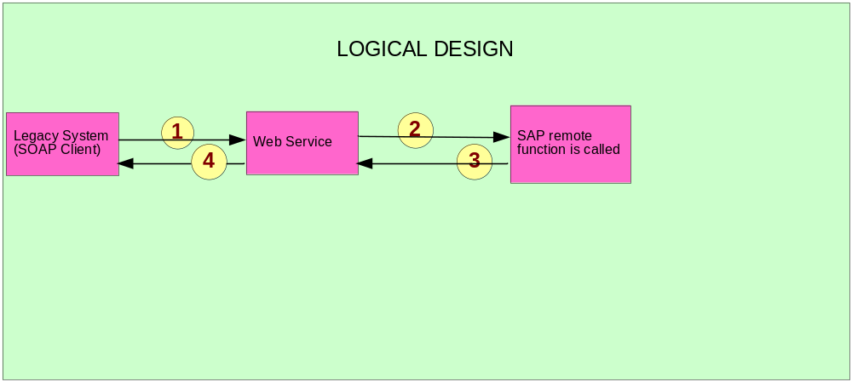 Figure 1: Logical Diagram for GetMaterialDetail

The logical design represents the submit order web services. Each request received from the SOAP client will always be converted to the SAP format before getting passed to SAP for processing.

Physical Architecture (Topology)
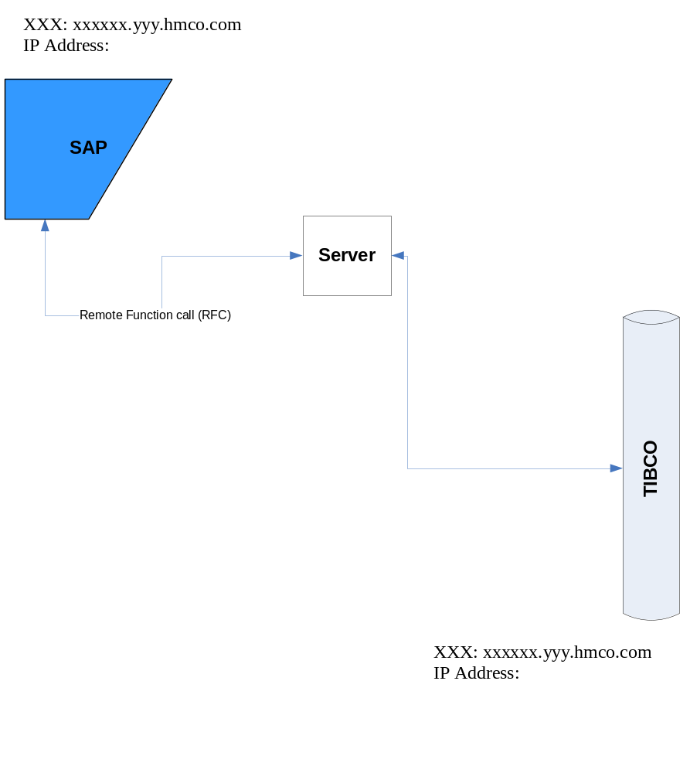
Figure 2: SAP TIBCO Physical Architecture

The physical architecture represents the SAP touch point with TIBCO for the GetMaterialDetail web service.

Event Flow

The message flow in the following message flow diagram represents the sequence of events for processing of request coming from the legacy systems.
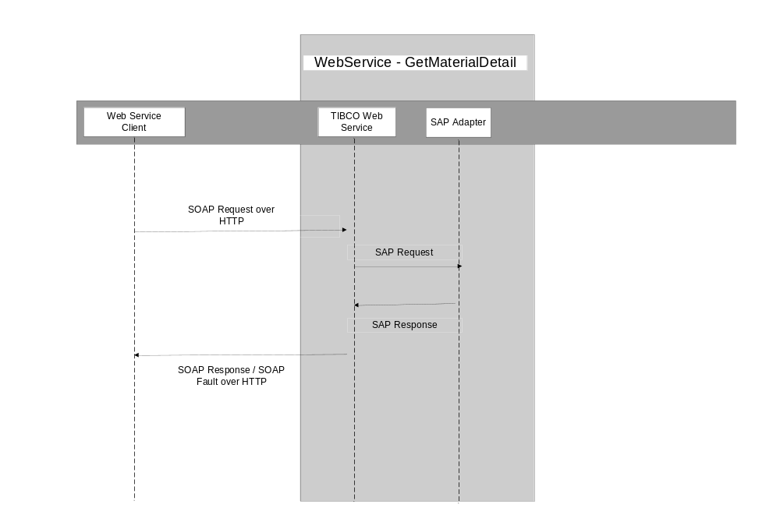

Block Diagram

The diagram below illustrates the flow, at a block level. The following section would outline the detailed flow for this service.

SOAP Event Entry
Call the SAP service
SOAP Reply

Activity Diagram
The figure below represents the processing steps for the GetMaterialDetail service
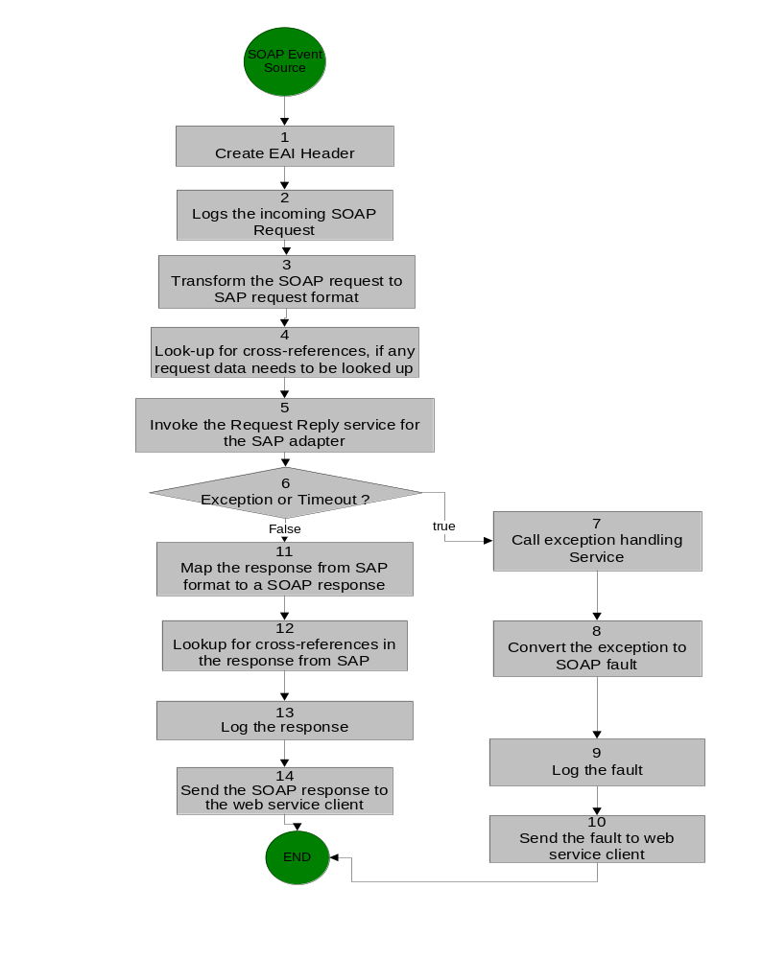

Figure 3: GetMaterialDetail Activity Diagram

Activity Detail

Activity. No. | Activity Detail
 | SOAP Event Source – It receives the request from the web services client
1 | Create the EAI header
2 | Log the incoming SOAP request
3 | Transform the SOAP request to SAP required format
4 | Perform look-up for any cross-references that may be required for the data in the incoming request
5 | Invoke the SAP request reply adapter passing the request
6 | If there is an exception or timeout go to next step, else go to step 11
7 | Call the exception handling routine
8 | Convert the exception to SOAP fault
9 | Log the SOAP fault
10 | Send the fault back to the web service client, and terminate
11 | Convert the SAP response to SOAP response
12 | Perform look-up for any cross-references that may be required for the data in the response
13 | Log the SOAP response
14 | Send the response back to the web service client, and terminate

Configuration Details

SAP Adapter Configuration Details

Property | Value
Application Server | Refer “SAP TIBCO Interface Configuration.xls”
System Number | Refer “SAP TIBCO Interface Configuration.xls”
Client | Refer “SAP TIBCO Interface Configuration.xls”
Username | Refer “SAP TIBCO Interface Configuration.xls”
Password | Refer “SAP TIBCO Interface Configuration.xls”
Name | EWS_ADR3_MaterialDetail
Transport Type | JMS
Wire Format | XML
Delivery Mode | Durable
Connection Factory Type | Queue
The location for the sheet is:
“My eRooms > Sunrise Technical > Technical > Documentation > TIBCO > Design > Adapters > SAP Adapter > SAP TIBCO Interface Configuration.xls”

Schema
Property | Value
Select RFC | Z_RFC_GET_MATERIAL_DETAIL

JMS Specifications
Property | Value
Transport type | JMS Queue / JMS Topic
Delivery mode | Persistent / Durable
Destination Queue / Topic Name | Refer to the JMS script: “My eRooms > Sunrise Technical > Technical > Documentation > TIBCO > Design > EMS Queue Configuration > common_TIBCO_IC_DEV.jmsscript
SSL | No

Use Cases

Use Case Id | Use Case Description
SAP_01 | eCommerce gets the material detail in real-time by means of web service provided by SAP through TIBCO by passing in one material ID
SAP_02 | eCommerce gets the material detail in real-time by means of web service provided by SAP through TIBCO by passing in a list of four material Ids
SAP_03 | eCommerce gets the material detail in real-time by means of web service provided by SAP through TIBCO by passing in a one ISBN number
SAP_04 | eCommerce gets the material detail in real-time by means of web service provided by SAP through TIBCO by passing in a list of four ISBN numbers

Key Performance Indicators / Metrics

There is a SLA for the interface to respond in 60 seconds, end to end. If no response is generated in this time frame, the interface would time out and return a timeout error to the eCommerce/VASPA client. When a timeout error occurs, there is no guarantee about the transaction status. It may or may not be processed by SAP. The client could try re-submitting the request at some later point of time.

Logging and Error Handling

Sensitivity Requirement for Logging – No.

Note: From functional perspective, each submission request shall be atomic and shall either succeed or fail in its entirety. The call shall fail if any error is detected. As this is not an update, the issue of failure midway through the process is not a problem.
All TIBCO projects log messages and errors to a central core technical services project. Every event that crosses the TIBCO boundaries is logged. Exceptions are also logged. Below is a list of exceptions that will be handled by this process.

Please see the HMCo Core Technical Services document for further details for the logging and exception service.

Activity | Exception Scenario | Exception Type | Comments
Adapter | SAP Adapter down | System | SAP will send the data to TIBCO once the SAP adapter is up and running
Adapter | SAP down | System | SAP will send the data once the SAP is up and running.
Mapper | Data transformation | Business | All lexical errors will be captured via the restrictions defined in the schema. These errors will be categorized as “ERROR_CATEGORY_VALIDATION”, and the error message generated by TIBCO must be sent back to the client.
Adapter Request-Reply Service | Error  returned by the RFC | Business / System | The RFC has an export parameter “RETURN_STATUS_CODE” which would be set to a non zero value for errors. If it 1 then errorCateogry =ERROR_CATEGORY_BUSINESS and if it is 2 errorCategory= “ERROR_CATEGORY_SYSTEM”. However is should be noted that for SAP returning “RETURN_STATUS_CODE” = 1, we would not be sending error, back to client. Client will see it as success. We will only create error for logging it to CTS, client does not see it as error.

Please refer to the “My eRooms > Sunrise Technical > Technical > Documentation > TIBCO > Design > Sunrise TIBCO Standards > Sunrise Error Handling Strategy.doc” for details on error handling.

Mapping Detail

Refer to the Mapping Excel sheet “HMCO_Sunrise_OTS_GetMaterialDetail_TIBCO_Mapping.xls”

Cross Reference Details

There would be cross-references on the request path.
For the response sheet the following six fields need to be looked up:

- MaterialStatus
- MaterialGroup
- Restrictions
- MediaType
- ProductDivision
- TermUnit

For details on the cross-reference values, please refer to the following document:
“My eRooms > Sunrise Technical > Technical > Documentation > TIBCO > Design > Sunrise TIBCO Standards > CrossReference Worksheet.xls (Enterprise-Wide Cross Reference tab)”

For details on the cross-reference lookup strategy, please refer to the following document:
“My eRooms > Sunrise Technical > Technical > Documentation > TIBCO > Design > Sunrise TIBCO Standards > HMCO Sunrise Reference Data Strategy.doc”

Business Works Component Inventory

The components used or updated as part of this specification will be selected and configured based on the detailed information captured in the activity diagram and activity diagram description. The same is true for the processes that will be generated or called as part of the specification.

In order to follow best practices for single-source data, the information will not be re-captured in this document. Rather, the information will be available through Business Designer via XML Canon when needed. XML Canon is the design-time repository for all TIBCO BW components, processes and projects. XML Canon also has capabilities to run component inventory reports and the ability to setup custom reporting as necessary.

The XML Canon repository that corresponds to this document is:

http://neduapp001.hmco.com:8088/Sunrise/Enterprise_Webservices

Assumptions

The client has a specific request for errors. SAP could pass back three types of status – namely success, business exception and system exception. Client is not interested in SAP business exception, hence even if SAP returns business exception, we do not want to send it back to the client. We will however create error schema for a SAP business exception, for TIBCO logging purpose. But we will return back success. This is required because the client assumes that there should not be a SAP business exception for this interface.

For SAP system exception, we would return a system exception back.
For all TIBCO generated exceptions, we should be returning back the exception to the client.

Issues

There is one open item – client is trying to get one more input parameter, customer ID which if comes, would be a CR.

Sign-off

Name | Role | Date | Signature
Arun Bhandari | Spec Writer | 10/10/2005
Dan Lambeth | Process Owner | 10/10/2005
Robie Gould | SAP Tech Spec Owner | 10/10/2005

